
Assignment 3
Ambarish Bhagawati
10731884
WORD DOCUMENT
Document Version / Details: Ver. 2.0/ 14-Nov-2022

1. What is bucket field in reports?
Ans: These are a feature in Salesforce that allow you to categorize or group records based on te values in a single field. They are often used for data visualization, reporting, and to create custom groupings without altering the source data.

2. Please share merchandise records with another user(which you newly created into your org), if the stock is greater than 2000. but please make sure it should be shared with only a single user(which you have newly created). not with all internal users. Hint. Public Group

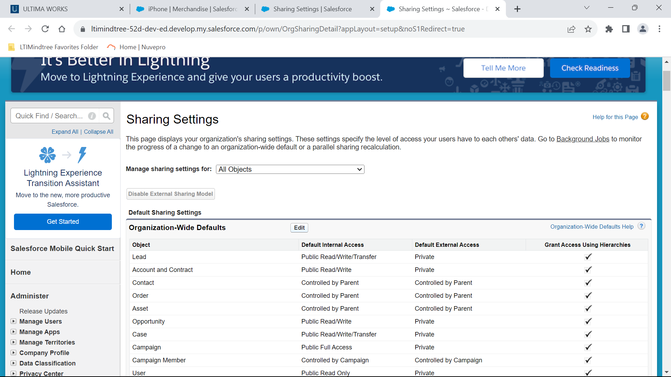
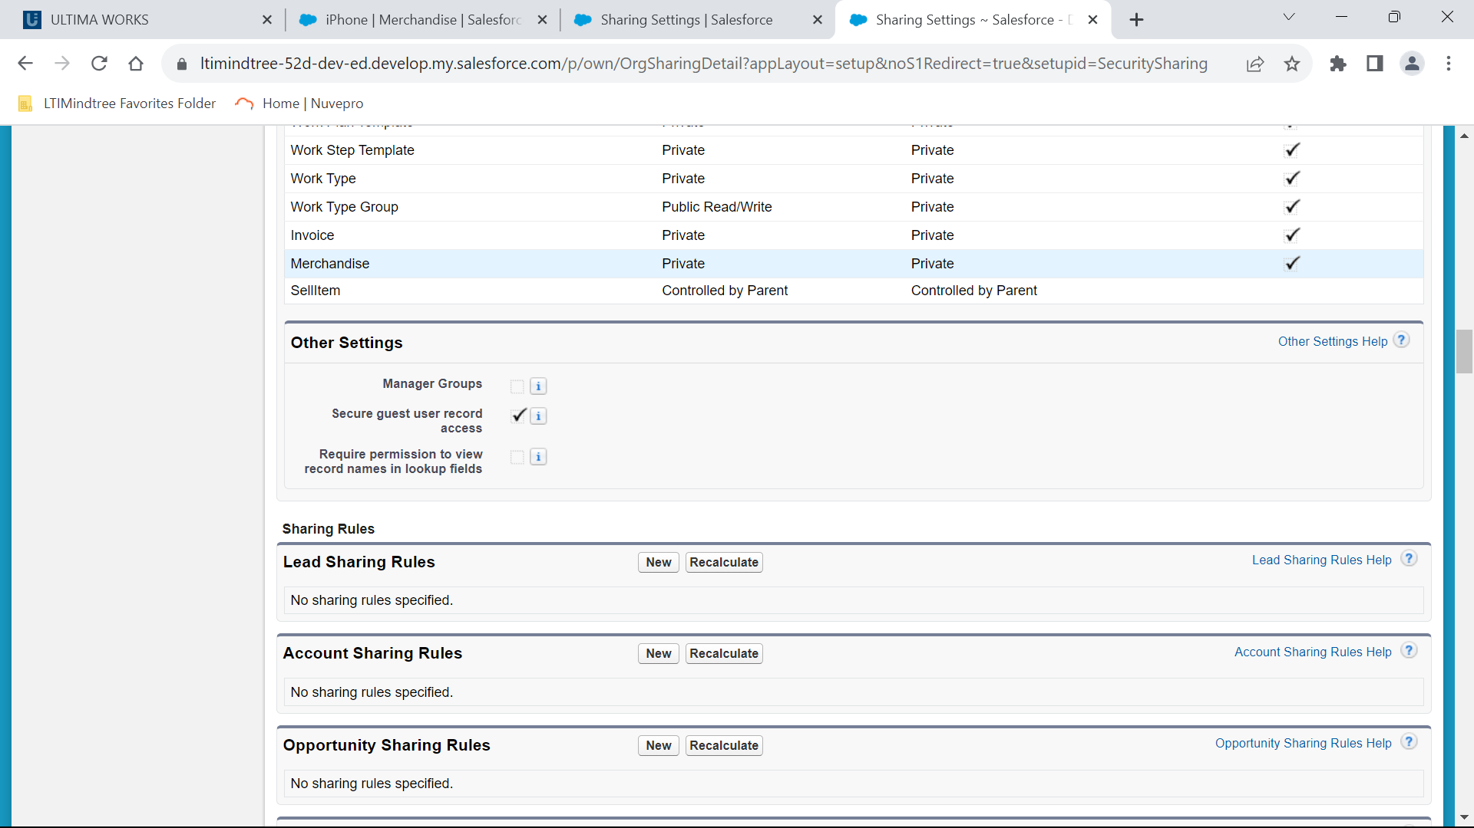
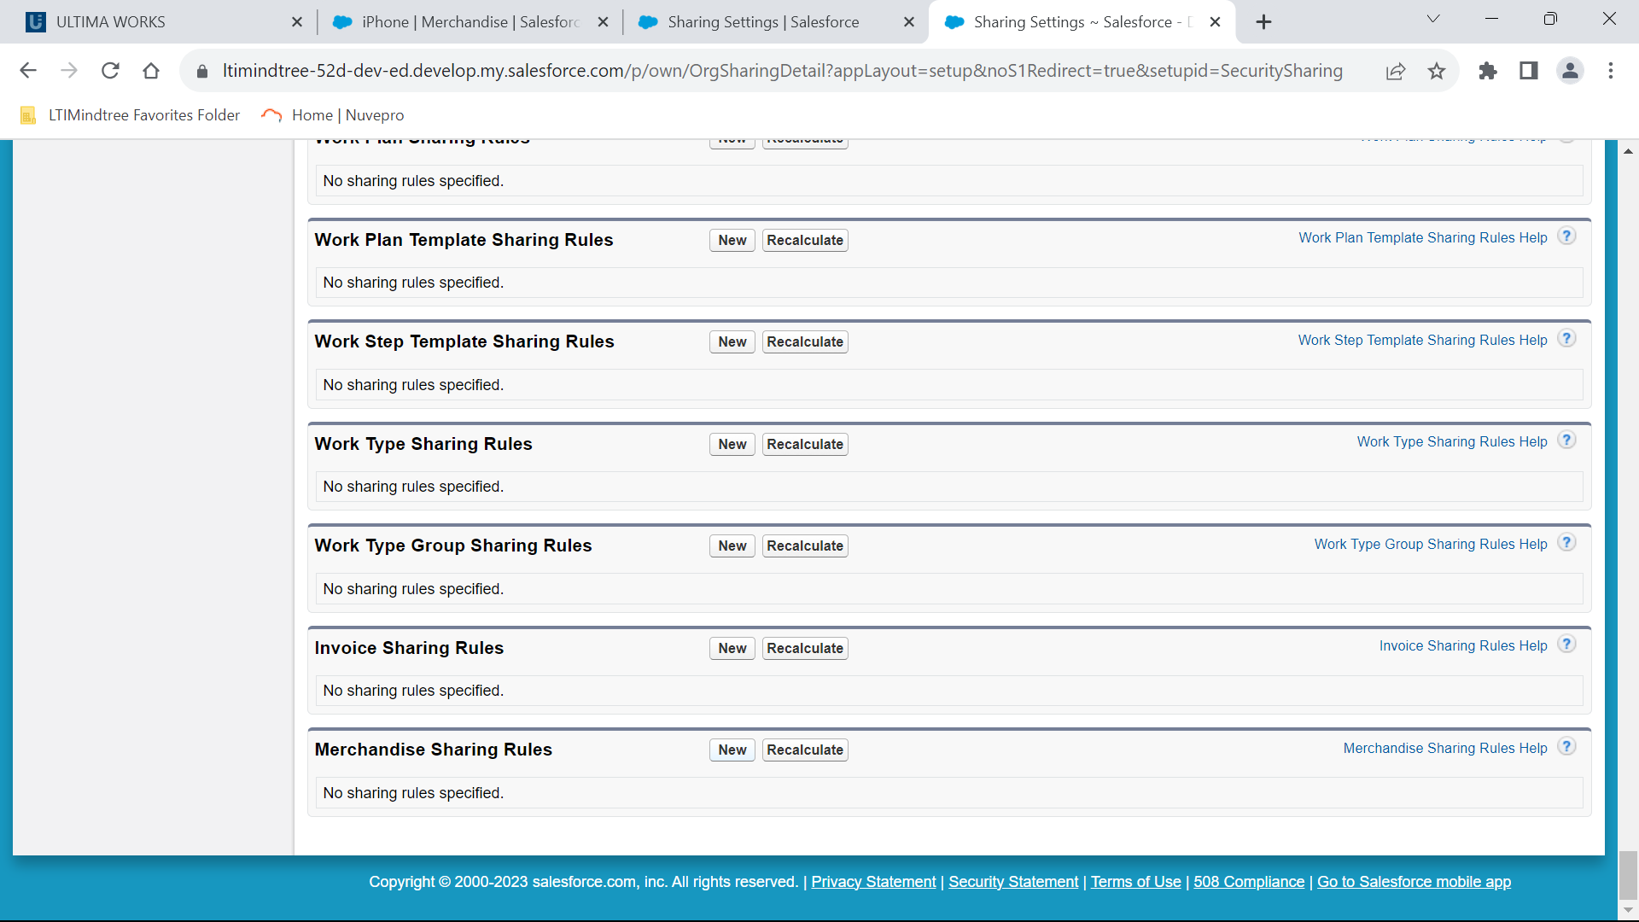
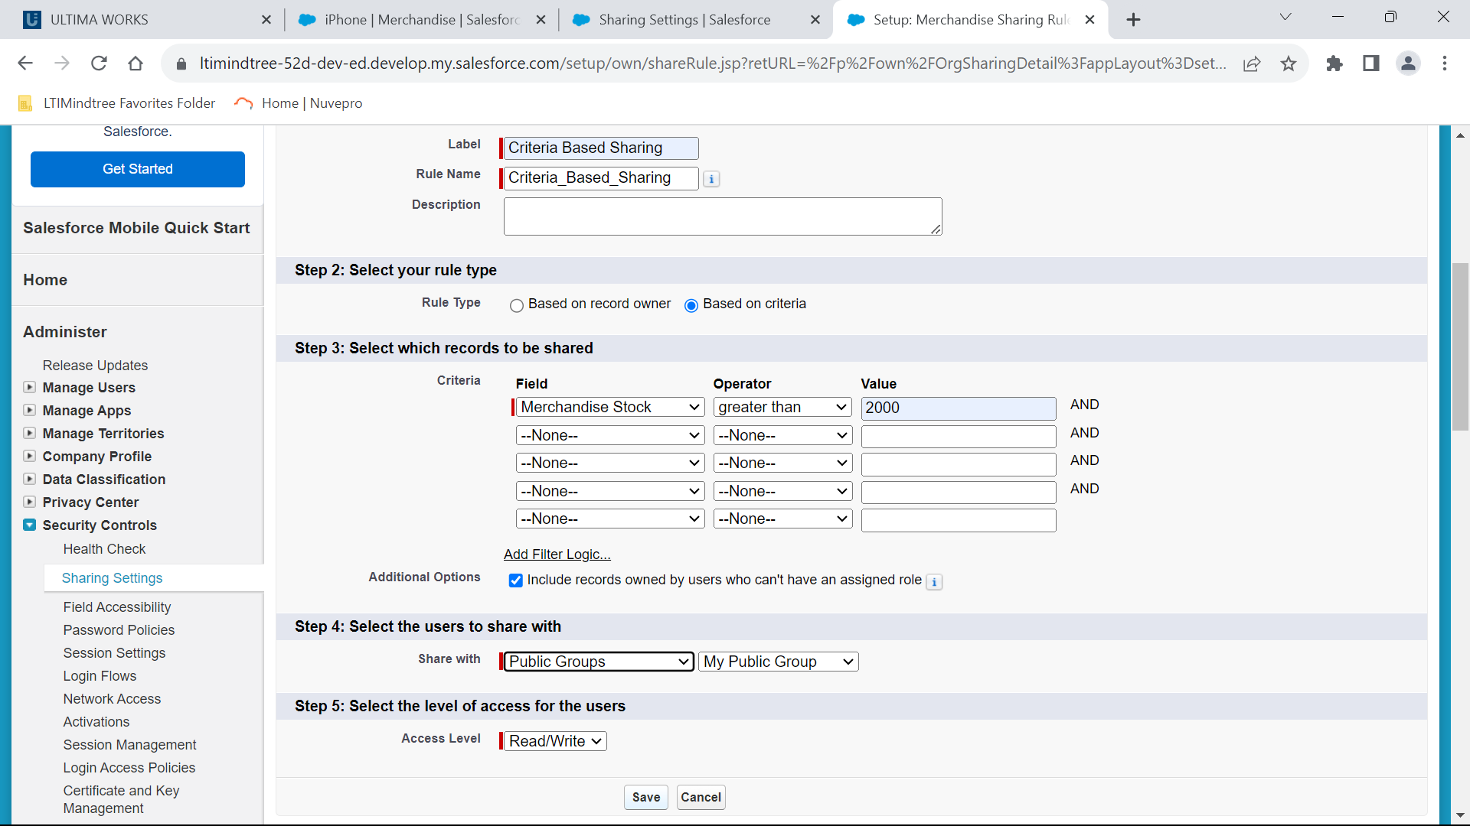

3. Share all the records of invoice object where you are owner with another user(which you have newly created).

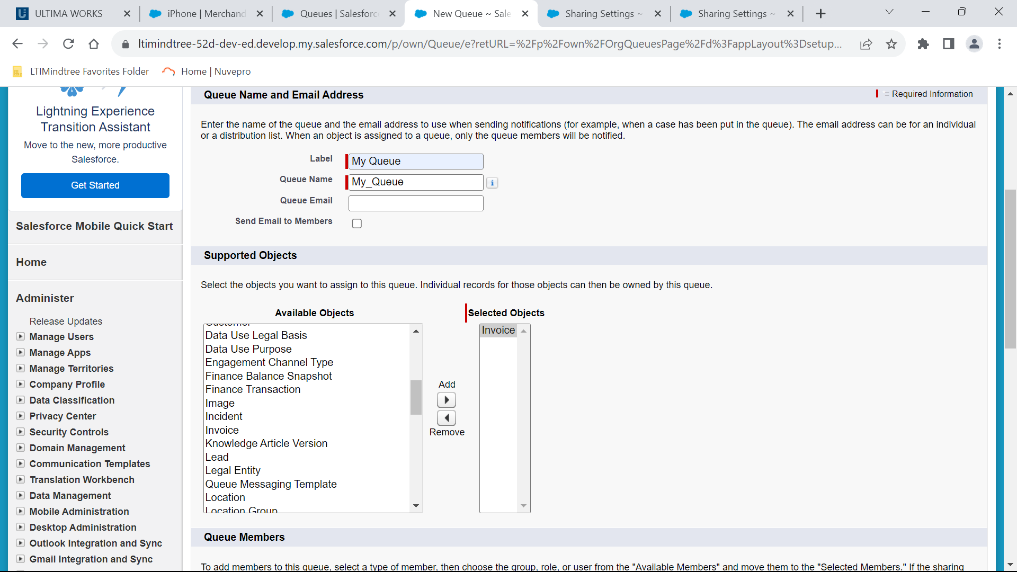
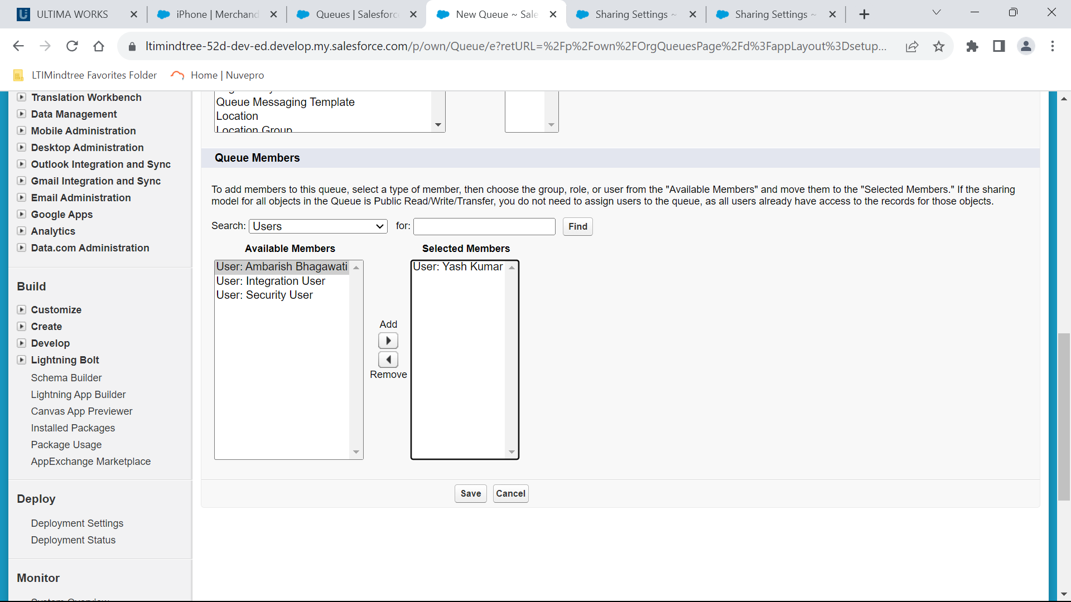
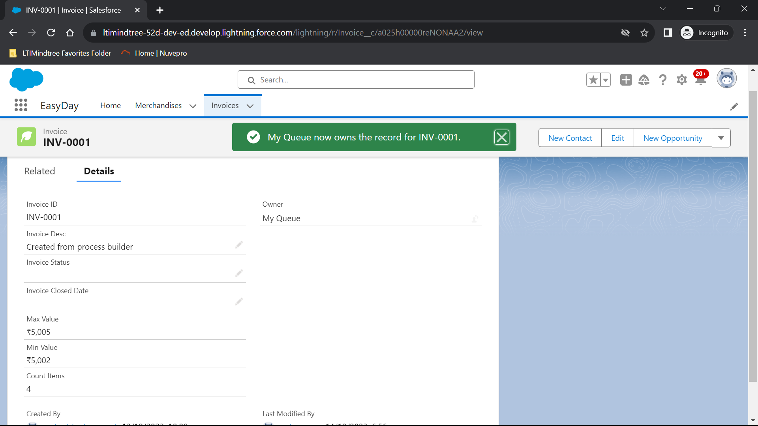

4. Can we controll the validation error message from pagelayout?
Ans : we can't directly control validation error messages from a page layout,we can controll the placement and styling of error mesages on the page layout through the salesforce lightning app builder. We can also specify related lists and related record layouts to influence how data is displayed.

5. You have not given any permission in the profile P1(new system admin)for an object O1(Merchandise), can another newly created user will be able to create records for object O1(Merchandise). How could this be this possible?If we want to do.

